**Jira Overview**

JIRA is an **Incident Management Tool** used for Project Management, Bug Tracking, Issue Tracking and Workflow. JIRA is based on the following three concepts – Project, Issue and Workflow.

JIRA

**Important Points to Note**

The following points explain some interesting details of JIRA.

* + JIRA is an incident management tool.
  + JIRA is developed by **Atlassian Inc.**, an Australian Company.
  + JIRA is a platform independent tool; it can be used with any OS.
  + JIRA is multi-lingual tool – English, French, German, Japanese, Spanish, etc.
  + JIRA supports MySQL, Oracle, PostgreSQL and SQL server in the backend.
  + JIRA can be integrated with many other tools – Subversion, GIT, Clearcase, Team Foundation Software,Jenkins, Slack , Mercury, Concurrent Version System and many more.
  + Jira Exposes the Rest-API

## License and Free Trial

The following points describes the legalities of the JIRA Tool.

* + JIRA is a commercial tool and available as a Trial version for a limited time.
  + To utilize JIRA services, a license is required.
  + JIRA provides free license for academic projects.
  + A 15-day trial version is available for an individual person to use.

## Use of JIRA

Following are some of the most significant uses of JIRA.

* + JIRA is used in Bugs tracking management
  + JIRA is useful in Project/Test Management which includes test case management, Incident Management tool
  + Task tracking Management tool
  + Requirement Management

**Advantages of Jira**

* + JIRA can be used in Helpdesk, Support and Customer Services to create tickets and track the resolution and status of the created tickets.
  + Jira also help us to get the RTM metrics

EG: mapping below

**User Story**[Requirement ] 🡺 **Task** [Scenario]🡺 **Test** Case

* + Jira provide test development coverage
  + Jira provide test execution coverage for every new build
  + JIRA is very useful in Workflow and Process management.
  + JIRA also help us to track daily activity via Agile Board

## JIRA ─ Core Features

The following table explains some of the most important and commonly used features in detail for better understanding.

|  |  |  |
| --- | --- | --- |
| **S. No.** | **Core Features** | **Description** |
| 1 | **Boards** | JIRA supports Scrum and Kanban boards.  These boards provide an immediate snapshot of the project to the team.  Helps to quickly review the progress of the project and see the status of the individual tasks.  Board workflow can be customized to fulfil the way a team wants to proceed. |
| 2 | **Business Project Template** | JIRA supports **n** number of business templates to manage simple tasks and complex tasks like workflow.  Template can be customized based on the team and their approach. Ex: Workflow can be customized based on each team's approach.  Every step is accounted and team can move to achieve their goals. |
| 3 | **Task Details** | Tasks can be defined at the individual level to track the progress.  Status of every task, comment, attachment and due dates are stored in one place. |
| 4 | **Notifications** | An email can be sent for a particular task to the users.  Voting and watching features to keep an eye on the progress for the stakeholders.  Use **@mention** to get the attention of a specific team member at Comments/Description.  User will instantly notify if something is assigned or if any feedback is required. |
| 5 | **Power Search** | JIRA supports a powerful search functionality with Basic, Quick and Advanced features.  Use the search tool to find answers like due date, when a task was last updated, what items a team member still needs to finish.  Project information at one place, search within a project. |

|  |  |  |
| --- | --- | --- |
| 6 | **Reports** | JIRA supports more than a dozen reports to track progress over a specific timeframe, deadlines, individual’s contribution, etc.  Easy to understand and generate different reports those help to analyse how the team is going on.  Easy to configure these reports and display the matrices to the stakeholders. |
| 7 | **Scale with Team Growth** | JIRA supports any business team and any project irrespective of size and complexity. |
| 8 | **Add -Ins** | JIRA supports more than 100 add-ins to connect with different software to make work easy.  Wide range of add-ins makes it as universal across the globe. |
| 9 | **Multilingual** | JIRA supports more than 10 languages those are widely used as English (US, UK, India), French, German, Portuguese, Spanish, Korean, Japanese and Russian. |
| 10 | **Mobile App** | JIRA is available as a Mobile Application as well.  It is available on Google Play Store and App Store (iTunes) of Apple.  Easy to stay connected with the team while moving anywhere with notification, comments and project activity. |

**JIRA – Project**

A Project contains issues; a JIRA project can be called as a collection of issues. A JIRA Project can be of several types. For example –

JIRA

* + Software Development Project
  + Marketing Project
  + Migration to other platform project
  + Help Desk Tracking Project
  + Leave Request Management System
  + Employee Performance System
  + Website Enhancement

## Create a New Project

## In Jira select Project-> Create new Project

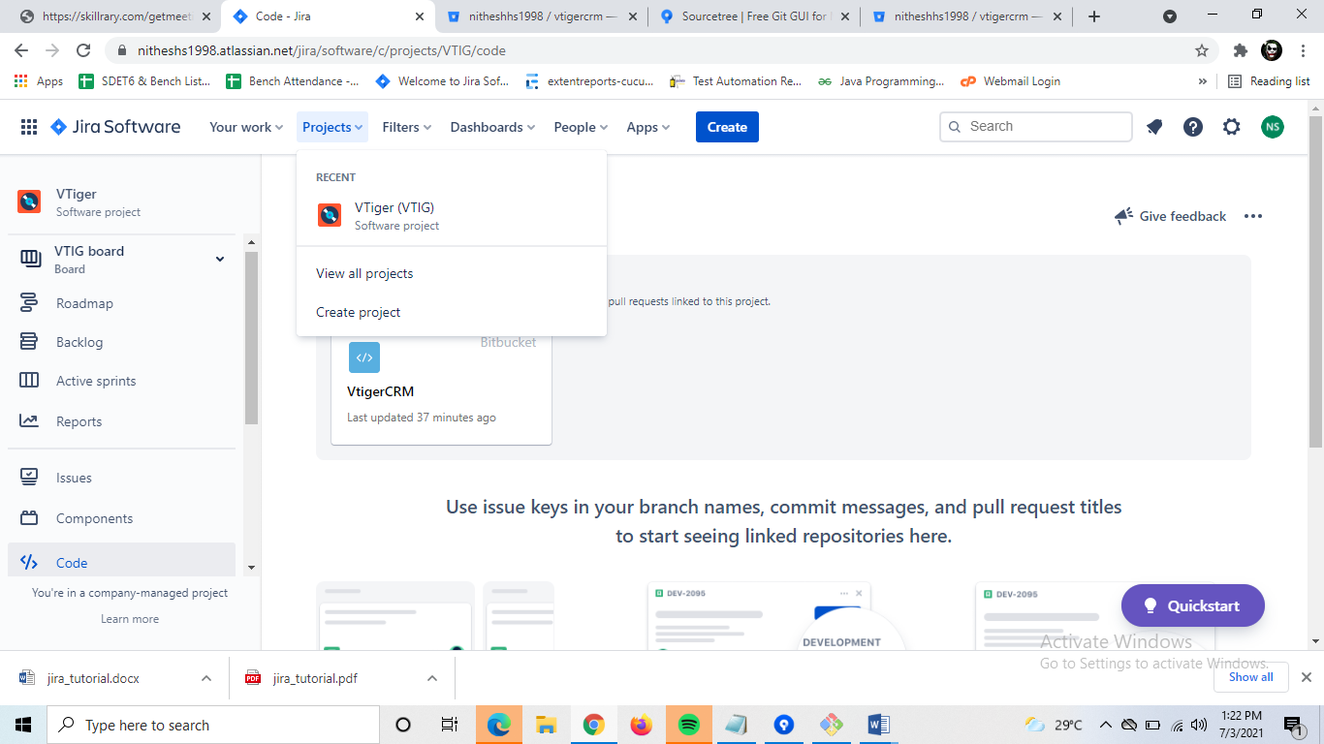

Mention the project Name -> click on create project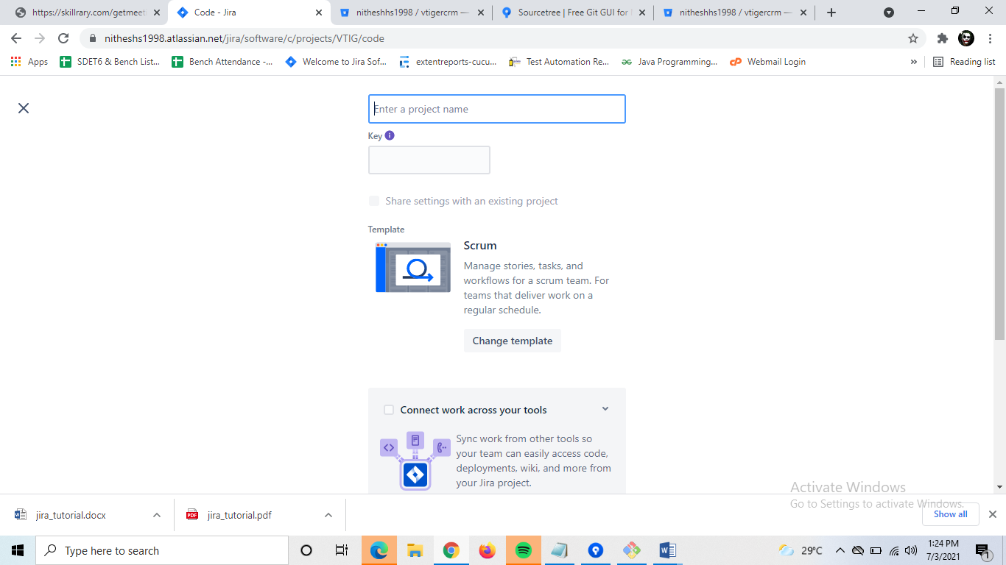

**JIRA Issues**

JIRA is a project management tool and uses issues to track all the tasks. An issue helps to track all works that underlie in a project. In real time, every work or task either technical, non-technical, support or any other type of a project in JIRA are logged as an issue.

An issue can be dependent on the organization and requirements:

* + Epic of a project
  + Story of a project
  + Task of a story
  + Sub-task of a story
  + A defect or bug can be an issue
  + Test to create a test case
  + Test Plan : set of test case
  + Test Execution: create test set for execution

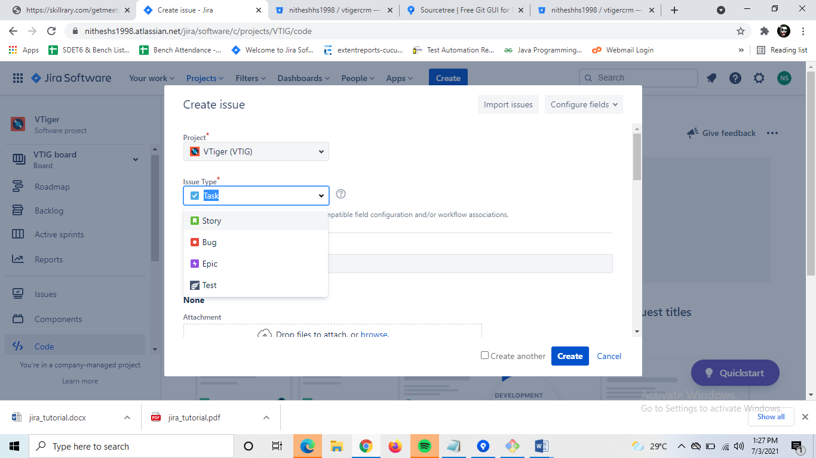

**Jira Workflow**

In JIRA, workflow is used to **track the lifecycle of an Issue**. Workflow is a record of statuses and transitions of an issue during its lifecycle. A status represents the stage of an issue at a particular point. An issue can be in only one status at a given point of time like Opened, To Do, Done, Closed, Assigned, etc.

A transition is a link between two statuses when an issue moves from one status to another. For an issue to move between two statuses, a transition must exist. In a simple way, a transition is some kind of work done on the issue, while status is the impact of work on that issue.

## Example

As of now, an issue is created and opened. When the assignee starts working on the issue, the issue moves to the **In Progress status**. Here, the transition is starting the work, while the status of the issue is now progressive.

JIRA workflow has the following stages to track as soon as an issue is created:

* + **Open Issue:** After creation, the issue is open and can be assigned to the assignee to start working on it.
  + **In Progress Issue:** The assignee has actively started to work on the issue.
  + **Resolved Issue:** All sub-tasks and works of that Issue are completed. Now, the issue is waiting to be verified by the reporter. If verification is successful, it will be closed or re-opened, if any further changes are required.
  + **Reopened Issue**: This issue was resolved previously, but the resolution was either incorrect or missed a few things or some modifications are required. From Reopened stage, issues are marked either as assigned or resolved.
  + **Close Issue:** The issue is considered as finished, resolution is correct as of now. Closed issues can be re-opened later based on the requirement.

JIRA Workflow can be referred as a **Defect Lifecycle**. It follows the same concepts; the only difference is that it is generic for all issues rather than limited to Defects only.

The following diagram shows a standard workflow:

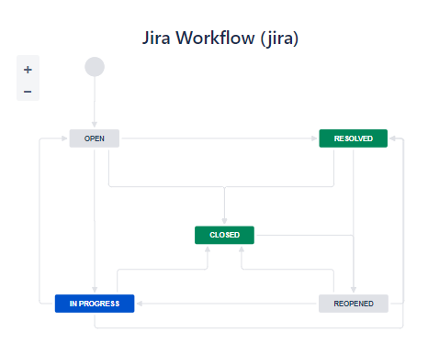

A transition is a one-way link, if an issue moves back and forth between two statuses; two transitions should be created.

**Example:** There are two-way transitions between closed and re-opened statuses. A closed issue can be reopened if any modifications are required at any time until the project completes, while a re-opened issue can be closed directly if additional work is taken care in another issue and no specific work has been done on the re-opened issue.

**Agile Board**

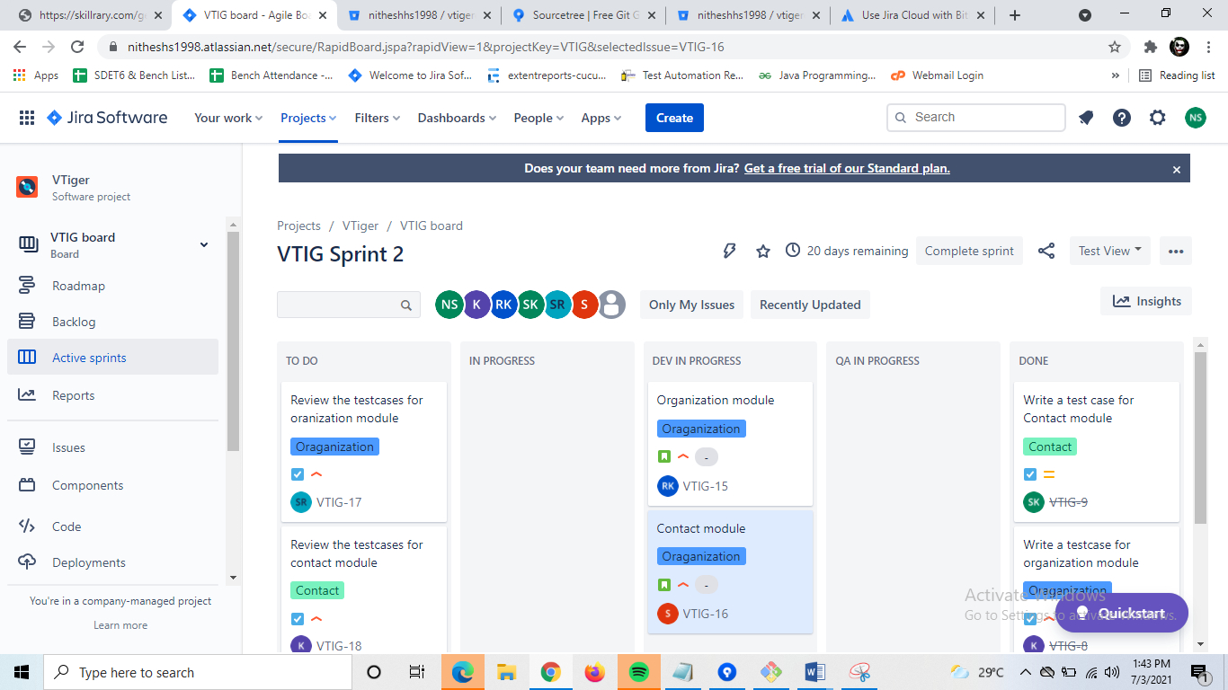

**Bug Report in Jira**

**Mandatory Information to create a bug report: -**

* Defect ID(Auto generate)
* Defect summary
* Defect description (steps to reproduce)
* Environment information
* Screenshot(attachment)
* priority
* Assign it to someone
* **Status-** All the statuses in the bug life cycle

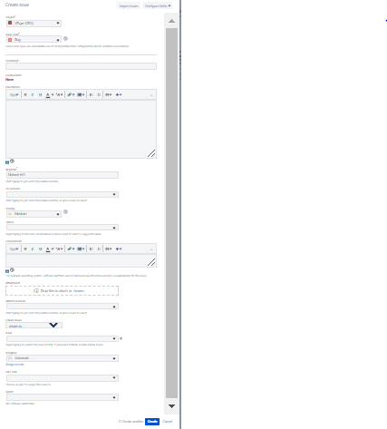

**Reports in Jira**

**Agile reports for scrum team:-**

* Sprint Report
* Burndown Chart
* Burnup Chart
* Epic Report
* Epic Burndown
* Velocity Chart
* Version Report
* Cumulative Flow Diagram

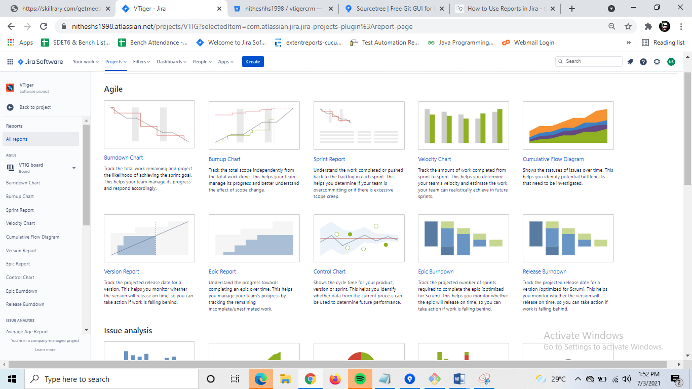

**Xray for Jira**

**Xary is a plugin used to write test cases in jira software**

**Installation of Xray plugin**

**1. C**lick on Apps -> find new apps -> search -> Xray -> Get Free

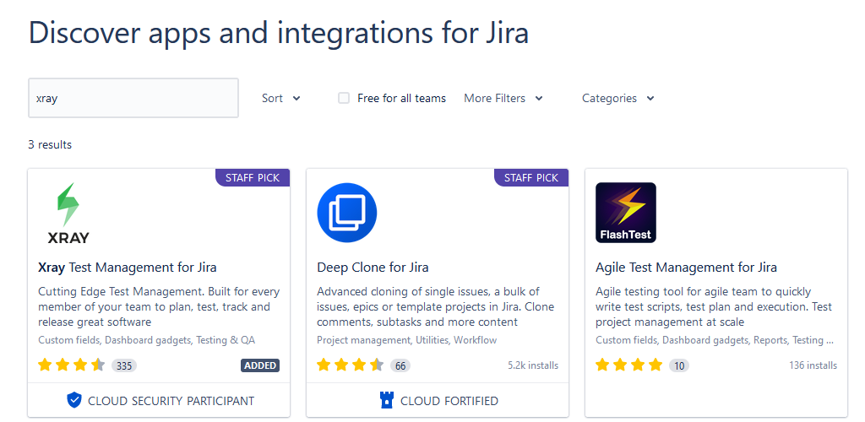

### **Configure Xray**

Go to Project 🡺 Project settings 🡺Apps 🡺 Xray settings 🡺 Summary 🡺 Add issue types

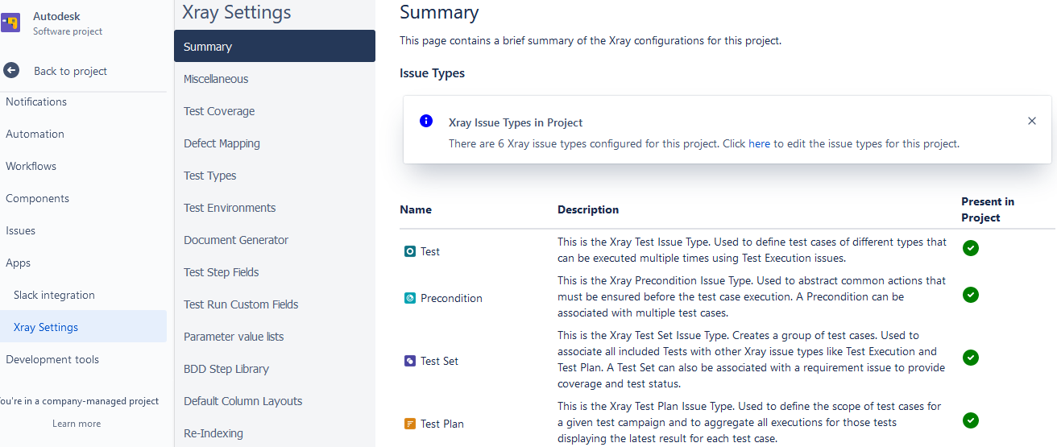

### **How to Create a Test?**

**1)** Click ‘Create’ (+) link. This will display a page as shown in the below image.

**2)** Make sure that the desired project, for which the tests are to be created, is selected in the ‘Project’ drop-down box.

**3)** Select ‘Test’ as the issue type in the ‘Issue Type’ drop-down box.

**4)** Enter the required details and other required additional information in the respective fields.

**Note**: Creating an issue of type ‘Test’ is similar to that of any other issue types like Bug, Task, etc.

**5)** Click the ‘Create’ button.

(i) This will create a new test, which is an issue of type ‘Test’.

[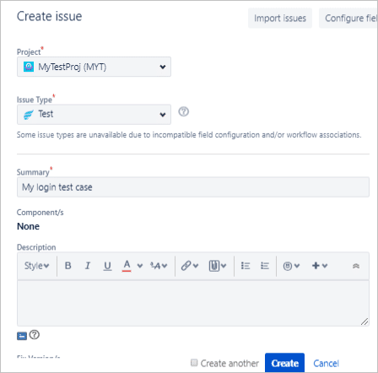](https://www.softwaretestinghelp.com/wp-content/qa/uploads/2018/10/createtest.png)

(ii) To add test steps and their details test issue needs to be modified.

### **Add Test Steps**

**(i)** Open the test to edit, preferably open the issue in a new browser tab. This will display a page as shown in the below image.

**(ii)** Go to ‘Test Details’ section and start adding details in ‘Test Step’, ‘Test Data’ and ‘Expected Result’ columns.

**(iii)** After adding the required details click on ‘Add Steps’ (button with icon available under the ‘Actions’ column.) button.

(a) This will add Step1 for the test.

**(iv)** Continue adding more steps, as required.

[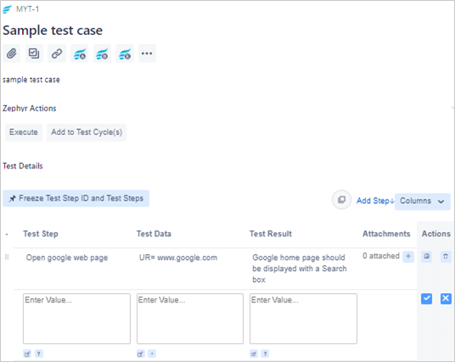](https://www.softwaretestinghelp.com/wp-content/qa/uploads/2018/10/addsteps.png)

* **Edit a step and its details:** Simply click on the cell of the ‘Test Step’ column and then click the pencil icon. Make the required changes and then click outside the cell. (This editing action is similar to the one which is done in Microsoft Excel).

**=>** Similarly, modify ‘Test Data’ and ‘Expected Result’ columns.

**=>** Attachment (say for instance an excel file with details of configuration) can be added by clicking on ‘Add attachment’ button (a button with icon + available under ‘Attachment’ column of the respective step).

* **Executing the test cases**

🡺Before executing the test cases create a Test Plan or Test Execution

* Add test cases to test plan
* Create a new test execution
* Then execute test case then changes the status